Snitch Fashion Sales - Summary
- Dataset Used:
The dataset Contains Sales Data of Snitch fashion Products including Shirts, T-Shirts, and Other Menswear Categories. It Includes Fields Such as Product Name, category, Quantity, Price, Discount, Total Sales, and Date, The Data Represents Real-World Fashion Retail Trends with Multiple Product Types and Pricing Ranges.

- Data Cleaning Steps:
- Removed Duplicate Records
- Handled Missing/Null Values
- Standardized Column Names
- Converted Data Types (Date, Numeri Fields)
- Checked And Corrected Inconsistent values (e.g., Price, quantity)
- Created Calculated Columns (total = price * quantity-discount)

- Formulas used (Excel)
- Total Sales: = Price * Quantity
- Discount Amount: = Price * Discount %
- Final Amount: = Total Sales – Discount
- Percentage Calculation: = (Part/Total)*100
- Pivot Tables for Summarizing Category-wise and Product-wise Sales

- Key Insights
- Jeans And T-Shirt Contribute The Highest Sales Volume
- Discounted Products Show Higher Purchase Trends
- Mid-Range Priced Products Generate The Maximum Revenue
- Seasonal Trends Affect Sales Performance

- DASHBOARD
- Interactive Dashboard Created Using Excel
- Includes:
Sales by Category
Revenue Trends
Top Products
Discount Analysis
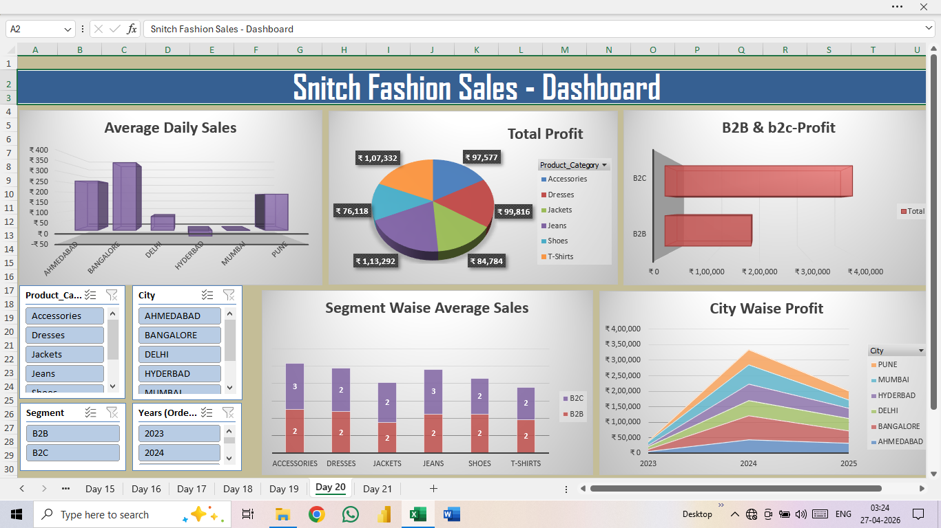
- Visual Elements: BarChart, Pie Charts, KPI Carts.

